* ACTIVITY DIAGRAM
* ACTIVITY HR LOGIN

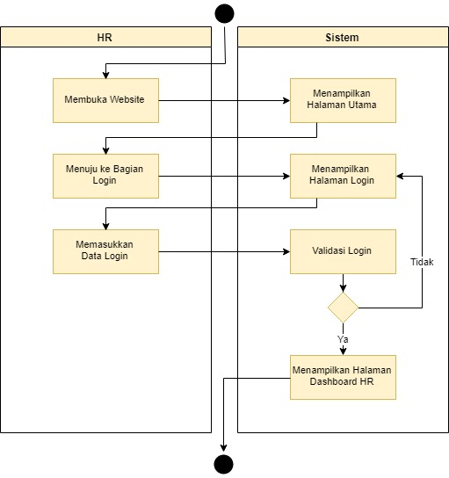

* ACTIVITY HR ADD MANAGER

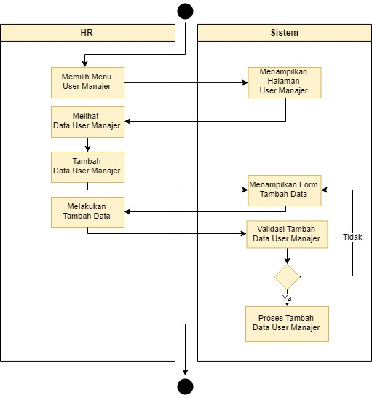

* ACTIVITY HR UPDATE MANAGER

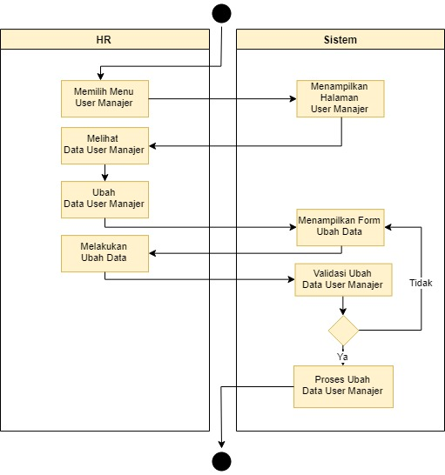

* ACTIVITY HR DELETE MANAGER

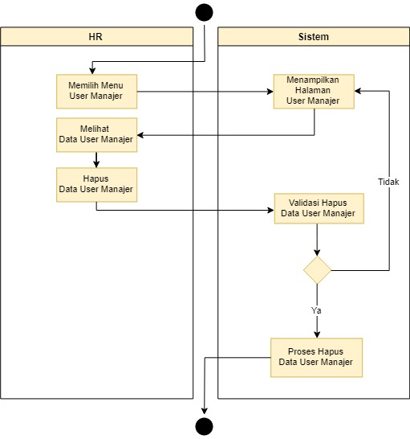

* ACTIVITY HR ADD MENTOR

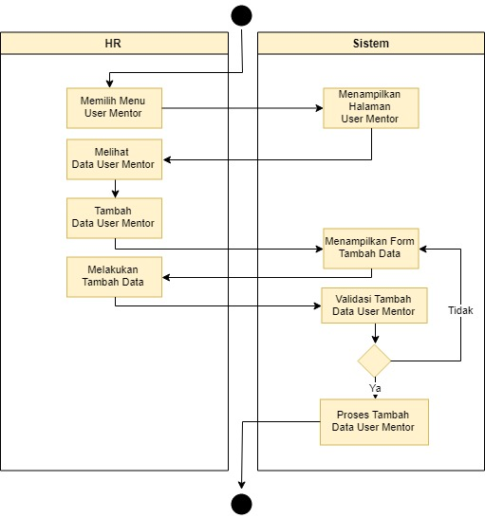

* ACTIVITY HR UPDATE MENTOR

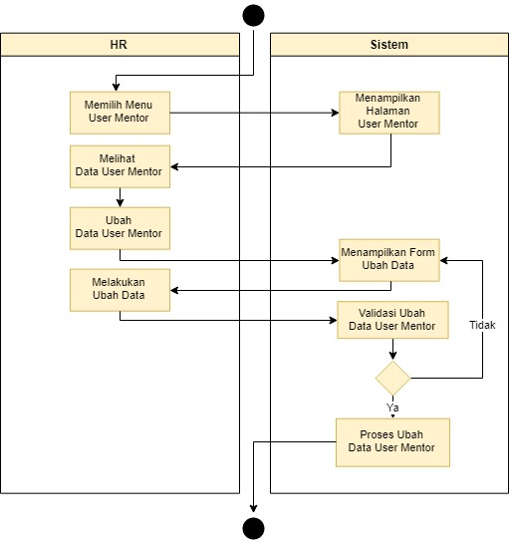

* ACTIVITY HR DELETE MENTOR

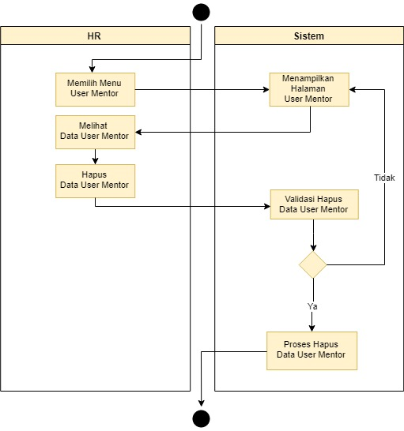

* ACTIVITY HR ADD STUDENT

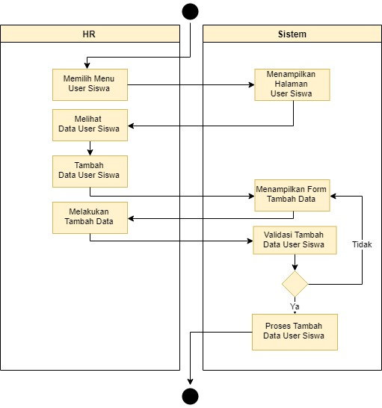

* ACTIVITY HR UPDATE STUDENT

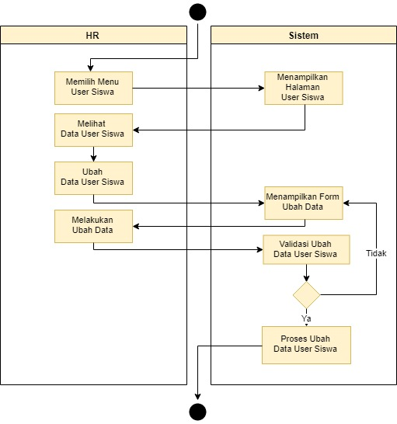

* ACTIVITY HR DELETE STUDENT

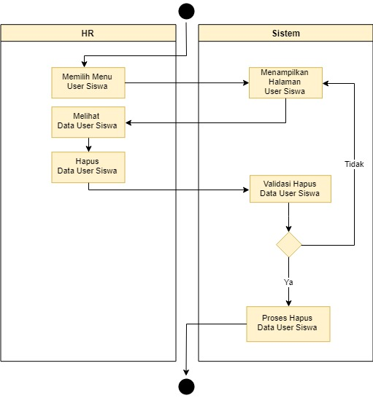

* ACTIVITY HR BLOCK STUDENT

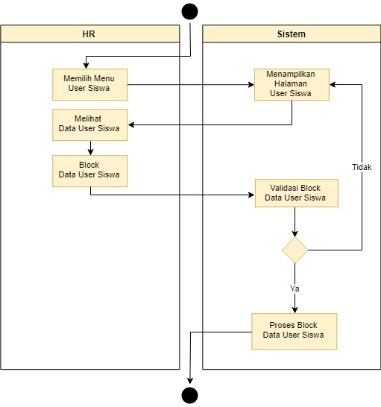

* ACTIVITY MENTOR LOGIN

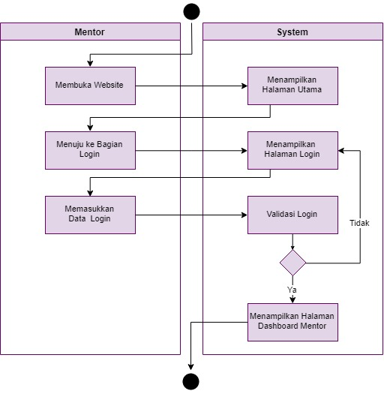

* ACTIVITY MENTOR ADD SCHEDULE

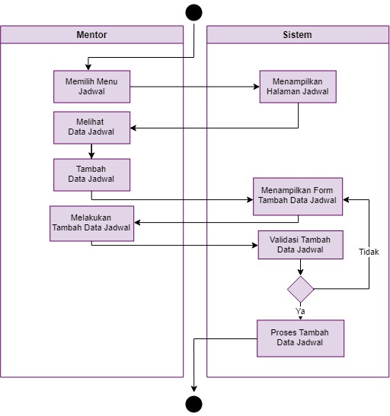

* ACTIVITY MENTOR UPDATE SCHEDULE

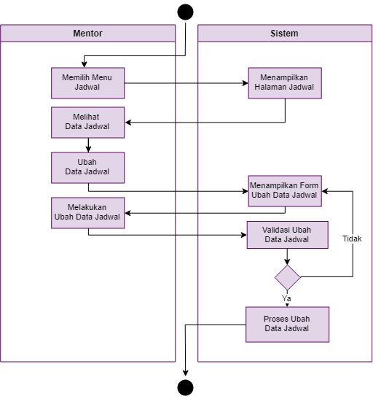

* ACTIVITY MENTOR DELETE SCHEDULE

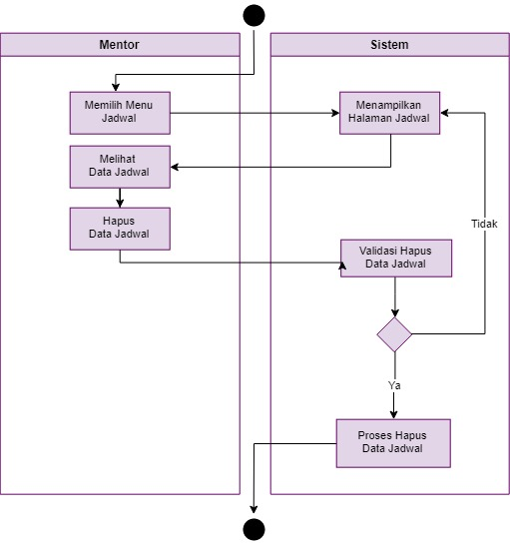

* ACTIVITY MENTOR ADD LESSON

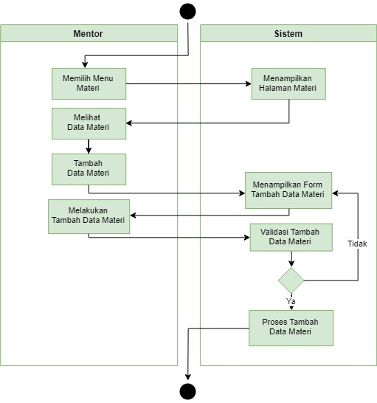

* ACTIVITY MENTOR UPDATE LESSON

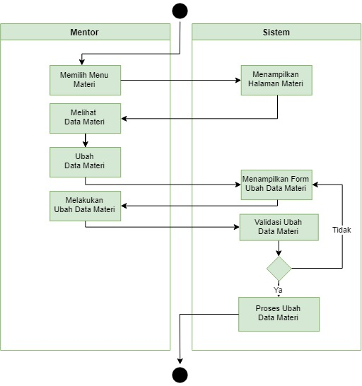

* ACTIVITY MENTOR DELETE LESSON

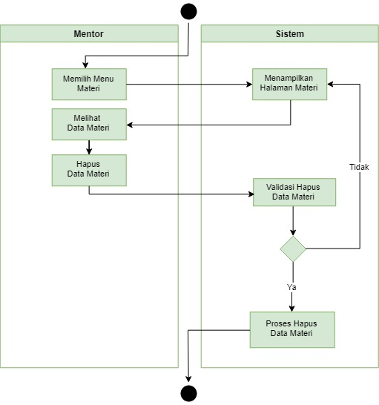

* ACTIVITY MENTOR ADD SCORE

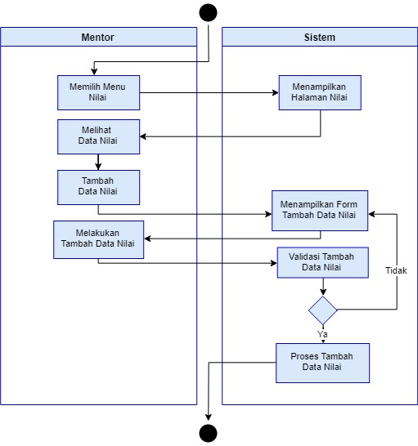

* ACTIVITY MENTOR UPDATE SCORE

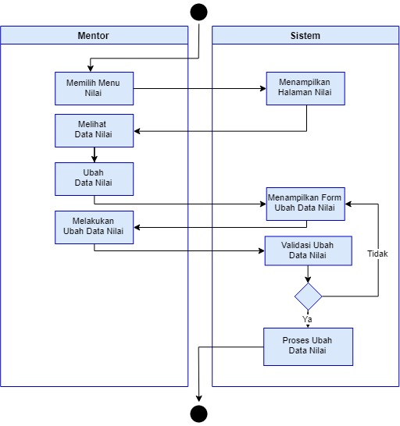

* ACTIVITY MENTOR HAPUS SCORE

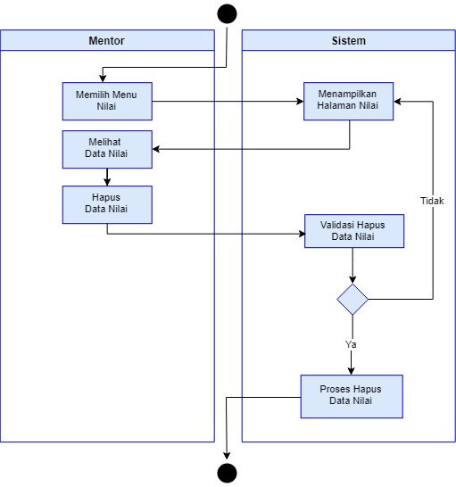

* ACTIVITY MENTOR VIEW ERRORBANK

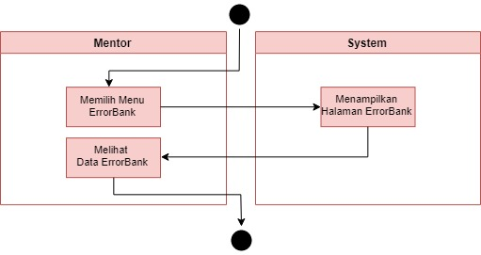

* ACTIVITY STUDENT LOGIN

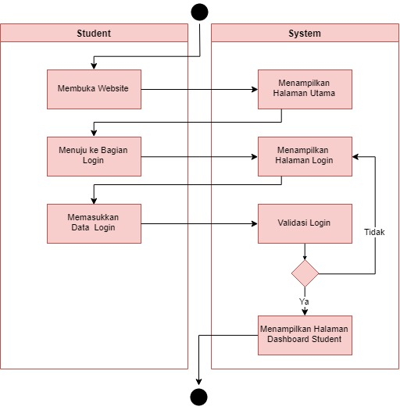

* ACTIVITY STUDENT UPDATE PROFILE

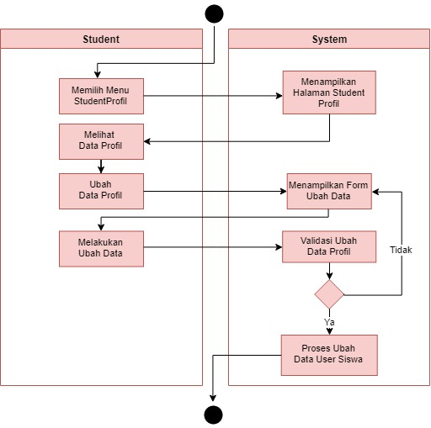

* ACTIVITY STUDENT VIEW SCHEDULE

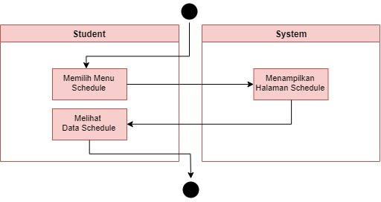

* ACTIVITY STUDENT VIEW LESSON

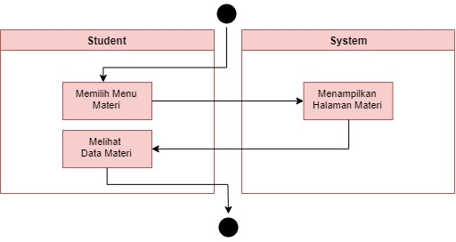

* ACTIVITY STUDENT VIEW DOWNLOAD LESSON

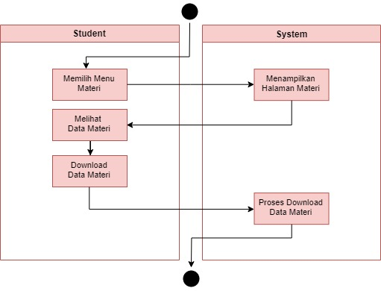

* ACTIVITY STUDENT VIEW SCORE

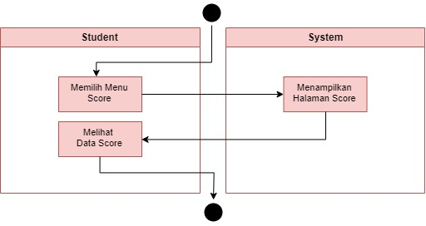

* ACTIVITY STUDENT ADD ERRORBANK

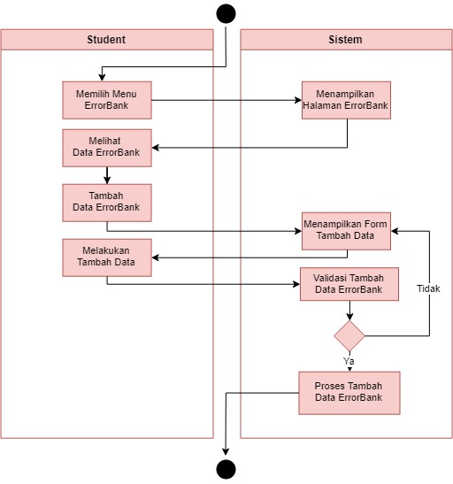

* ACTIVITY STUDENT UPDATE ERRORBANK

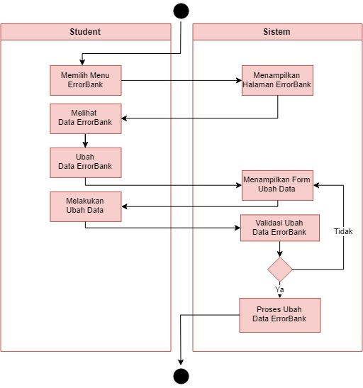

* ACTIVITY STUDENT DELETE ERRORBANK

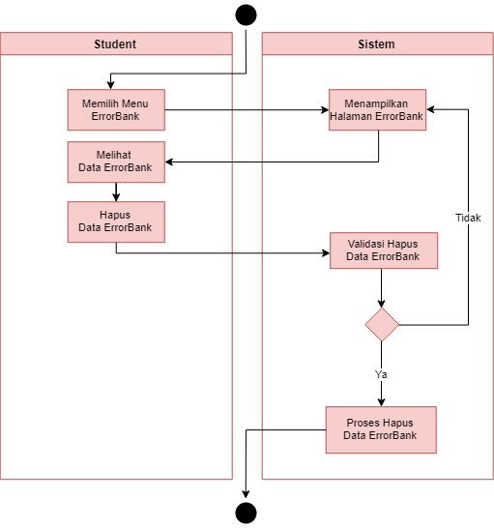

* ACTIVITY MANAGER LOGIN

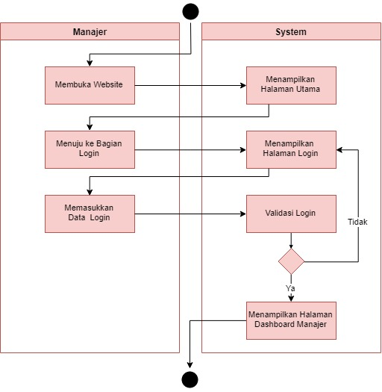

* ACTIVITY MANAGER VIEW STUDENT

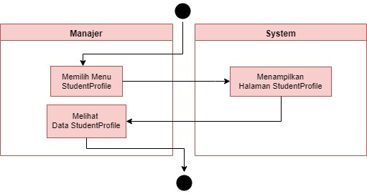

* ACTIVITY MANAGER VIEW SCORE STUDENT

